**Lab Assignment 3**

**Please, type the required commands and insert screenshots in the word document then submit it on Blackboard for “Assignment 3”**

**Also, this lab assignment MUST be done on Fedora Server VM as part of the final project**

1- Open lab1 file located in ~/Mac232/projects/labs with vi command and add the following text then save the file:

“Far, we've been travaling far  
Without a home but not without a star  
Free, only want to be free  
We huddle close, hang on to a dream

On the boats and on the planes  
They're coming to America  
Never looking back again  
They're coming to America”

Answer:

command: vi lab1

to insert: i

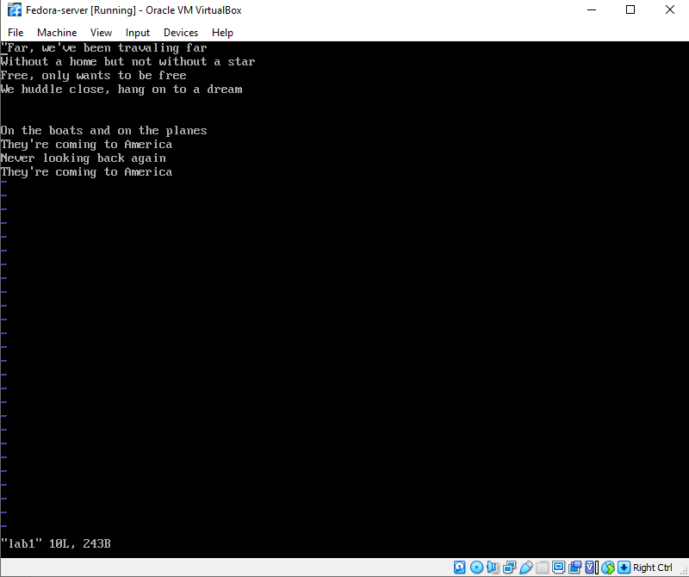

2- Open lab2 file located in ~/Mac232/projects/labs with vi command and add the following text then save the file:

“Home, don't it seem far away  
Oh we're traveling light today  
In the eye of the storm  
In the eye of the storm

Home, to a new and a shiny place  
Make our bed and we'll say our grace  
Freedom's light burning warm  
Freedom's light burning warm”

Answer:

Command: vi lab2

3- Create the file lab1-hlink that hard linked to lab1 in the directory path ~/Mac232/projects/labs

4- Create the file lab2-slink that soft linked to lab2 in the directory path ~/Mac232/projects/labs

5- Run the command ls –il ~/Mac232/projects/labs/lab* and insert a screenshot of the output

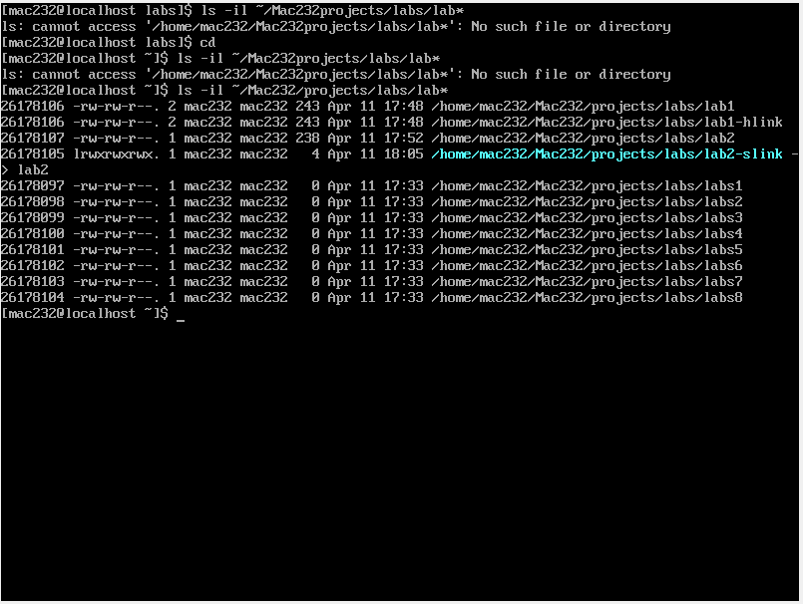

6- change the permission of lab1 file to be read, write and execute by the owner, read and write by the group and read only by others (use both symbolic and numeric permissions)

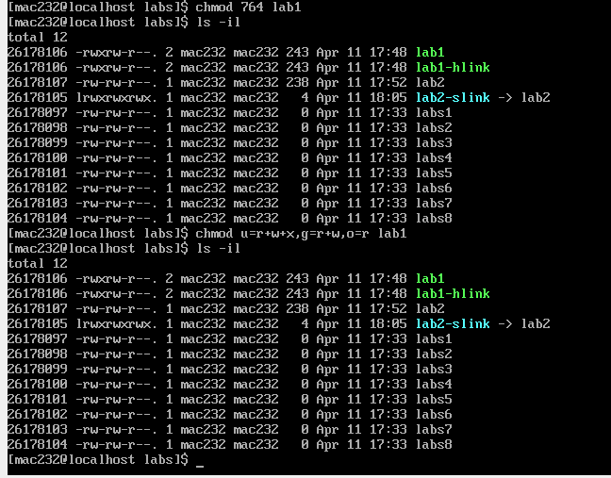

7- change the permission of lab2 file to be write and execute by the owner, read and execute by the group and execute only by others (use both symbolic and numeric permissions)

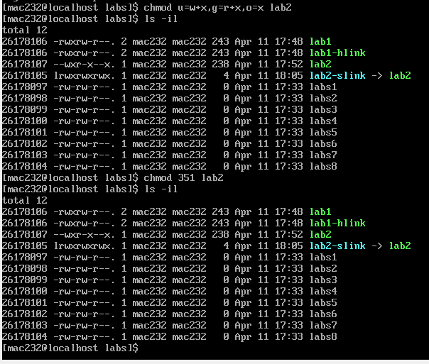

8- Run the command ls –il ~/Mac232/projects/labs/lab* and insert a screenshot of the output

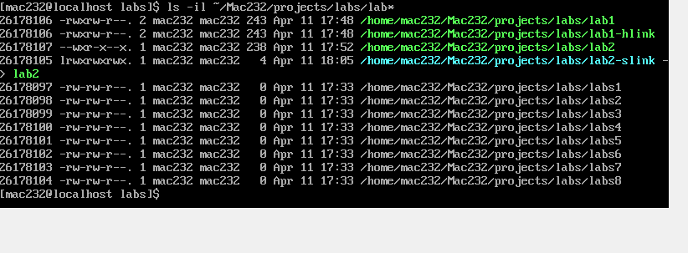

9- After the permissions of lab1 and lab2 have changed, have the permissions of lab1-hlink and lab2-slink changed too? Explain, why?

Answer: lab1-hlink is hard link and and lab2-slink is a soft link. In hard link when we use ln lab1-hlink lab1 command it creates a hard or exact copy of the original file and in soft link when we use ln -s lab2-slink lab2 it creates a link to original file. If user or group deletes hard link original file it will not crash because it will have hard link exact copy of original file and If user or group deletes soft link original file it will crash because it is just a link and source of data will deleted.

Hard link

Soft link

HARD DRIVE

HARD DRIVE